- Write the Python program to solve 8-Puzzle Problem:
Python code:
from collections import deque

def solve(start, goal):
queue = deque([(start, [])])
visited = {start}

moves = [(-1, 0), (1, 0), (0, -1), (0, 1)]

while queue:
state, path = queue.popleft()

if state == goal:
return path + [state]

zero = state.index(0)
x, y = divmod(zero, 3)

for dx, dy in moves:
nx, ny = x + dx, y + dy

if 0 <= nx < 3 and 0 <= ny < 3:
new_zero = nx * 3 + ny
new_state = list(state)
new_state[zero], new_state[new_zero] = \
new_state[new_zero], new_state[zero]
new_state = tuple(new_state)

if new_state not in visited:
visited.add(new_state)
queue.append((new_state, path + [state]))

return None

start = (1, 2, 3,
4, 0, 6,
7, 5, 8)

goal = (1, 2, 3,
4, 5, 6,
7, 8, 0)

solution = solve(start, goal)

if solution:
print("Solution:")
for state in solution:
for i in range(0, 9, 3):
print(state[i:i+3])
print()
else:
print("No solution exists")
output: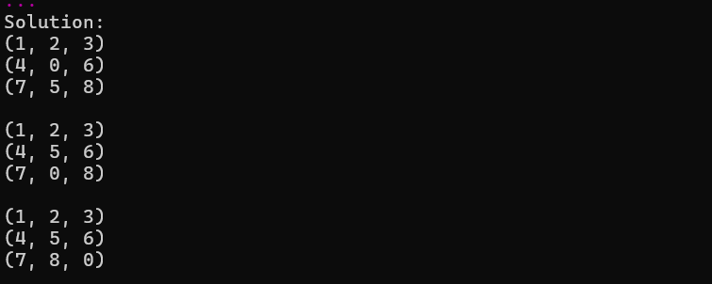
- Write the Python program to solve 8-Queen Problem.
def is_safe(board, row, col, n):
for i in range(row):
if board[i] == col or abs(board[i] - col) == abs(i - row):
return False
return True

def solve(board, row, n):
if row == n:
return True

for col in range(n):
if is_safe(board, row, col, n):
board[row] = col

if solve(board, row + 1, n):
return True

board[row] = -1

return False

n = int(input("Enter number of queens: "))

board = [-1] * n

if solve(board, 0, n):
print("\nSolution:")
for i in range(n):
for j in range(n):
if board[i] == j:
print("Q", end=" ")
else:
print(".", end=" ")
print()
else:
print("No solution exists")
Output:
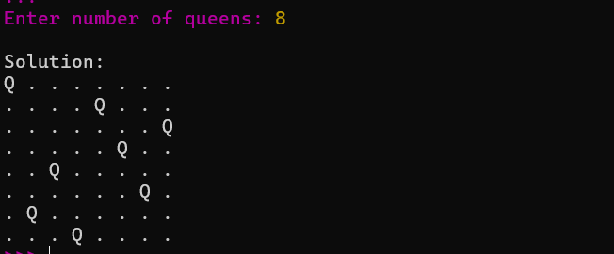

- Write the Python program for Water Jug Problem.
from collections import deque
from math import gcd

def water_jug(a, b, target):
if target > max(a, b) or target % gcd(a, b) != 0:
print("Solution not possible")
return

q = deque([(0, 0, [])])
visited = set()

while q:
x, y, path = q.popleft()

if (x, y) in visited:
continue

visited.add((x, y))
path = path + [(x, y)]

if x == target or y == target:
for step in path:
print(step)
return

states = [
(a, y), (x, b), (0, y), (x, 0),
(x - min(x, b-y), y + min(x, b-y)),
(x + min(y, a-x), y - min(y, a-x))
]

for state in states:
if state not in visited:
q.append((*state, path))

print("Solution not found")

a = int(input("Enter capacity of jug 1: "))
b = int(input("Enter capacity of jug 2: "))
target = int(input("Enter target amount: "))

water_jug(a, b, target)

output:
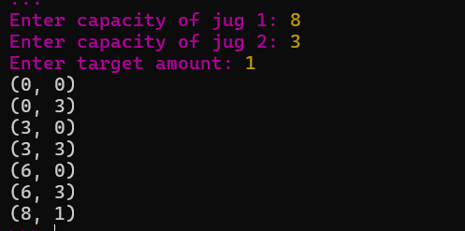

- Write the python program for Cript-Arithmetic problem
Aim: To solve a crypt-arithmetic puzzle in which each letter represents a unique digit.
Example: SEND + MORE = MONEY
from itertools import permutations

letters = "SENDMORY"
digits = "0123456789"

def solve():
for p in permutations(digits, len(letters)):
d = dict(zip(letters, p))

if d['S'] == '0' or d['M'] == '0':
continue

send = int(d['S'] + d['E'] + d['N'] + d['D'])
more = int(d['M'] + d['O'] + d['R'] + d['E'])
money = int(
d['M'] + d['O'] + d['N'] + d['E'] + d['Y']
)

if send + more == money:
print("SEND =", send)
print("MORE =", more)
print("MONEY =", money)
return

solve()

output:
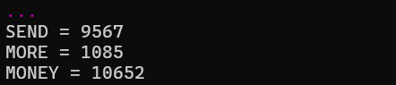

- Write the python program for Missionaries Cannibal problem
Aim: To solve the Missionaries and Cannibals problem using Breadth-First Search (BFS).
from collections import deque

def solve():
start = (3, 3, 1)
goal = (0, 0, 0)
moves = [(1, 0), (2, 0), (0, 1),
(0, 2), (1, 1)]

q = deque([(start, [start])])
visited = {start}

while q:
state, path = q.popleft()
m, c, boat = state

if state == goal:
print("Solution steps:")
for step in path:
print(step)
return

for x, y in moves:
if boat == 1:
nm, nc, nb = m-x, c-y, 0
else:
nm, nc, nb = m+x, c+y, 1

if not (0 <= nm <= 3 and 0 <= nc <= 3):
continue

if ((nm > 0 and nm < nc) or
(3-nm > 0 and 3-nm < 3-nc)):
continue

nxt = (nm, nc, nb)

if nxt not in visited:
visited.add(nxt)
q.append((nxt, path + [nxt]))

print("No solution")

solve()
output:
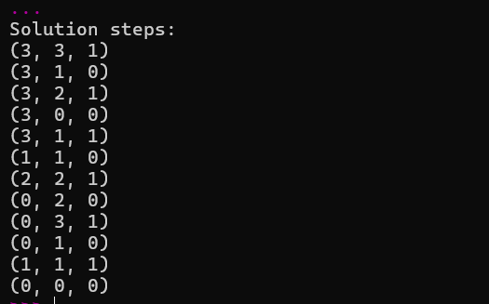

6. Python Program for the Vacuum Cleaner Problem
Aim: To clean two rooms using a simple vacuum cleaner agent. The user enters the initial condition of each room.
rooms = {
"A": input("Enter status of Room A (Dirty/Clean): ").strip().capitalize(),
"B": input("Enter status of Room B (Dirty/Clean): ").strip().capitalize()
}

position = input("Enter vacuum position (A/B): ").strip().upper()

if (any(v not in ("Dirty", "Clean") for v in rooms.values())
or position not in ("A", "B")):
print("Invalid input")
else:
while True:
print("\nVacuum is in Room", position)

if rooms[position] == "Dirty":
rooms[position] = "Clean"
print("Room", position, "cleaned")
else:
print("Room", position, "is already clean")

if all(status == "Clean" for status in rooms.values()):
print("All rooms are clean!")
break

position = "B" if position == "A" else "A"
print("Moving to Room", position)
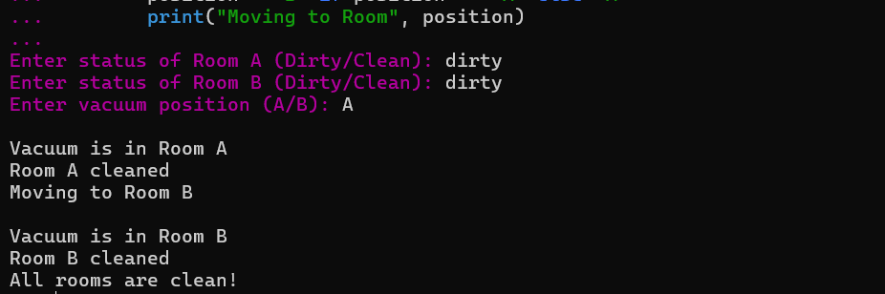
7. Python Program to Implement BFS (Breadth-First Search)
Aim: To traverse a graph using Breadth-First Search.
from collections import deque

graph = {}

n = int(input("Enter number of nodes: "))

for i in range(n):
node = input("Enter node name: ").strip()
neighbors = input(
"Enter neighbors of " + node + " separated by spaces: "
).split()
graph[node] = neighbors

start = input("Enter starting node: ").strip()

def bfs(graph, start):
visited = set()
queue = deque([start])

while queue:
node = queue.popleft()

if node not in visited:
print(node, end=" ")
visited.add(node)

for neighbor in graph.get(node, []):
if neighbor not in visited:
queue.append(neighbor)

if start in graph:
print("BFS Traversal:")
bfs(graph, start)
else:
print("Starting node not found")
output:
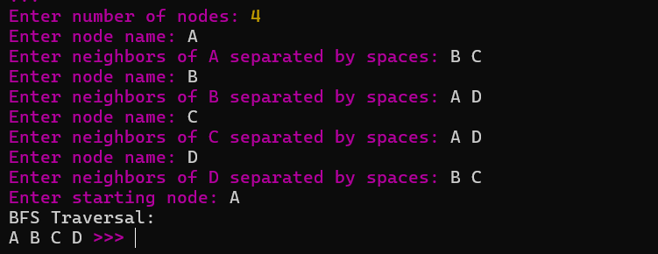
8. Python Program to Implement DFS (Depth-First Search)
Aim: To traverse a graph using Depth-First Search.
graph = {}

n = int(input("Enter number of nodes: "))

for i in range(n):
node = input("Enter node name: ").strip()
neighbors = input(
"Enter neighbors of " + node + " separated by spaces: "
).split()
graph[node] = neighbors

start = input("Enter starting node: ").strip()

def dfs(graph, node, visited):
if node in visited:
return

print(node, end=" ")
visited.add(node)

for neighbor in graph.get(node, []):
dfs(graph, neighbor, visited)

if start in graph:
print("DFS Traversal:")
dfs(graph, start, set())
else:
print("Starting node not found")
output:
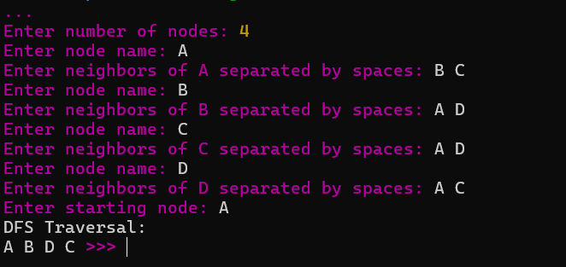

9. Python Program to Implement Travelling Salesman Problem (TSP)
Aim: To find the shortest route that visits every city exactly once and returns to the starting city.
from itertools import permutations

n = int(input("Enter number of cities: "))
dist = []

print("Enter distance matrix:")
for i in range(n):
dist.append(list(map(int, input().split())))

start = int(input(f"Enter starting city (0 to {n-1}): "))

if n < 2 or not 0 <= start < n:
print("Invalid input")
else:
cities = [i for i in range(n) if i != start]
min_cost = float('inf')
best_path = None

for p in permutations(cities):
path = (start,) + p + (start,)
cost = sum(dist[path[i]][path[i+1]]
for i in range(n))

if cost < min_cost:
min_cost = cost
best_path = path

print("Shortest path:", " -> ".join(map(str, best_path)))
print("Minimum cost:", min_cost)
output:
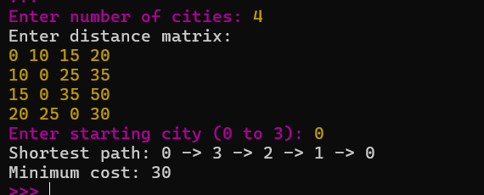
10. Python Program to Implement A* Algorithm
Aim: To find the shortest path between a starting node and a goal node using the A* search algorithm.
import heapq

graph = {}
heuristic = {}

n = int(input("Enter number of nodes: "))

for i in range(n):
node = input("Enter node name: ").strip()
heuristic[node] = int(input("Enter heuristic value: "))
graph[node] = {}

e = int(input("Enter number of edges: "))

for i in range(e):
u, v, w = input("Enter edge (from to cost): ").split()
w = int(w)
graph[u][v] = w
graph[v][u] = w

start = input("Enter start node: ").strip()
goal = input("Enter goal node: ").strip()

def astar(start, goal):
pq = [(heuristic[start], 0, start, [start])]
best = {start: 0}

while pq:
f, g, node, path = heapq.heappop(pq)

if g != best.get(node):
continue

if node == goal:
print("Shortest path:", " -> ".join(path))
print("Total cost:", g)
return

for neighbor, cost in graph[node].items():
new_g = g + cost

if new_g < best.get(neighbor, float('inf')):
best[neighbor] = new_g
heapq.heappush(
pq, (new_g + heuristic[neighbor],
new_g, neighbor, path + [neighbor])
)

print("No path found")

if start in graph and goal in graph:
astar(start, goal)
else:
print("Invalid start or goal node")
output:
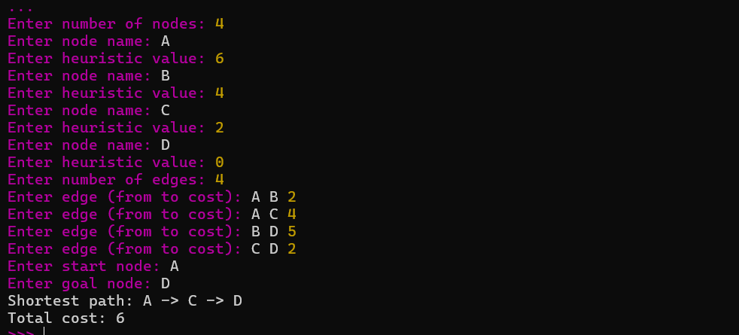
11. Python Program for Map Coloring Using CSP
Aim: To color map regions so that no two adjacent regions have the same color, using Constraint Satisfaction Problem (CSP) and backtracking.
regions = input("Enter regions separated by spaces: ").split()
colors = input("Enter colors separated by spaces: ").split()

graph = {}

for region in regions:
neighbors = input(
f"Enter neighbors of {region}: "
).split()
graph[region] = neighbors

assignment = {}

def safe(region, color):
for neighbor in graph[region]:
if assignment.get(neighbor) == color:
return False
return True

def solve():
if len(assignment) == len(regions):
return True

region = next(r for r in regions if r not in assignment)

for color in colors:
if safe(region, color):
assignment[region] = color

if solve():
return True

del assignment[region]

return False

if solve():
print("\nMap Coloring Solution:")
for region in regions:
print(region, ":", assignment[region])
else:
print("No valid coloring exists")
output:
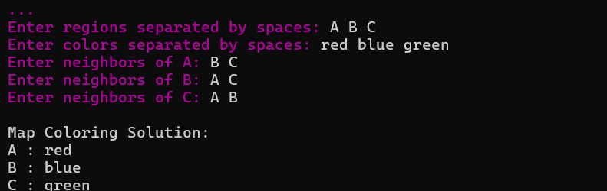

12. Python Program for Tic-Tac-Toe Game
Aim: To develop a two-player Tic-Tac-Toe game using Python.
board = [" "] * 9

def display():
for i in range(0, 9, 3):
print(" | ".join(board[i:i+3]))
if i < 6:
print("--+---+--")

def winner():
lines = [
(0, 1, 2), (3, 4, 5), (6, 7, 8),
(0, 3, 6), (1, 4, 7), (2, 5, 8),
(0, 4, 8), (2, 4, 6)
]

for a, b, c in lines:
if board[a] == board[b] == board[c] != " ":
return board[a]
return None

player = "X"

while True:
display()

try:
pos = int(input(
f"Player {player}, enter position (1-9): "
)) - 1
except ValueError:
print("Enter a number from 1 to 9.")
continue

if pos < 0 or pos > 8 or board[pos] != " ":
print("Invalid position! Try again.")
continue

board[pos] = player

if winner():
display()
print("Player", player, "wins!")
break

if " " not in board:
display()
print("Game is a draw!")
break

player = "O" if player == "X" else "X"
output:
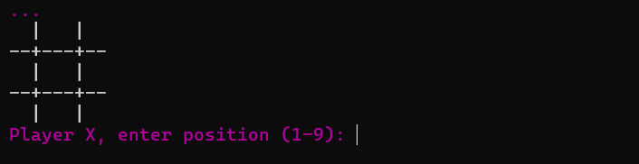
3. Python Program to Implement the Minimax Algorithm for Gaming
Aim: To implement the Minimax algorithm to choose the best move in a game tree.
def minimax(depth, index, maximizing, scores, max_depth):
if depth == max_depth:
return scores[index]

if maximizing:
return max(
minimax(depth + 1, index * 2, False,
scores, max_depth),
minimax(depth + 1, index * 2 + 1, False,
scores, max_depth)
)
else:
return min(
minimax(depth + 1, index * 2, True,
scores, max_depth),
minimax(depth + 1, index * 2 + 1, True,
scores, max_depth)
)

n = int(input("Enter number of leaf nodes (power of 2): "))
scores = list(map(int, input("Enter leaf scores: ").split()))

if (n != len(scores) or n < 2
or n & (n - 1) != 0):
print("Invalid input: enter 2, 4, 8, ... leaf scores.")
else:
depth = n.bit_length() - 1
result = minimax(0, 0, True, scores, depth)
print("Best value using Minimax:", result)
output:
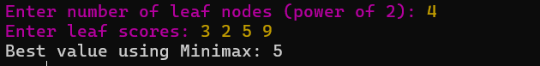

14. Python Program to Implement Alpha-Beta Pruning Algorithm for Gaming
Aim: To implement the Alpha-Beta Pruning algorithm to find the best move in a game tree while reducing unnecessary searches.
def alphabeta(depth, index, maximizing, scores,
alpha, beta, max_depth):

if depth == max_depth:
return scores[index]

if maximizing:
best = float('-inf')

for i in range(2):
value = alphabeta(
depth + 1, index * 2 + i, False,
scores, alpha, beta, max_depth
)
best = max(best, value)
alpha = max(alpha, best)

if beta <= alpha:
break

return best

else:
best = float('inf')

for i in range(2):
value = alphabeta(
depth + 1, index * 2 + i, True,
scores, alpha, beta, max_depth
)
best = min(best, value)
beta = min(beta, best)

if beta <= alpha:
break

return best

n = int(input("Enter number of leaf nodes: "))
scores = list(map(int, input("Enter leaf scores: ").split()))

if n != len(scores) or n < 2 or (n & (n - 1)) != 0:
print("Enter a valid power-of-2 number of scores.")
else:
depth = n.bit_length() - 1

result = alphabeta(
0, 0, True, scores,
float('-inf'), float('inf'), depth
)

print("Best value:", result)
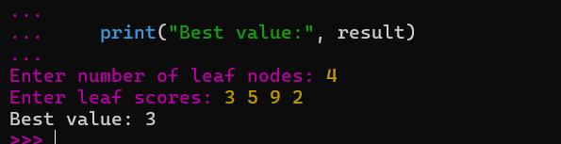
15. Python Program to Implement a Decision Tree
Aim: To implement a Decision Tree classification algorithm using the scikit-learn library.
from sklearn.tree import DecisionTreeClassifier

# Training data
X = [
[20, 5000],
[25, 6000],
[30, 8000],
[35, 10000],
[40, 12000],
[45, 15000]
]

# 0 = No, 1 = Yes
y = [0, 0, 0, 1, 1, 1]

model = DecisionTreeClassifier(random_state=0)
model.fit(X, y)

age = int(input("Enter age: "))
salary = int(input("Enter salary: "))

prediction = model.predict([[age, salary]])

if prediction[0] == 1:
print("Prediction: Yes")
else:
print("Prediction: No")

16. Python Program to Implement a Feed-Forward Neural Network
Aim: To implement a simple Feed-Forward Neural Network using Python and the scikit-learn library.
from sklearn.neural_network import MLPClassifier

# Training data: two input features
X = [
[0, 0],
[0, 1],
[1, 0],
[1, 1]
]

# Target output: XOR operation
y = [0, 1, 1, 0]

model = MLPClassifier(
hidden_layer_sizes=(4,),
activation='tanh',
solver='lbfgs',
max_iter=5000,
random_state=1
)

model.fit(X, y)

a = int(input("Enter first input (0 or 1): "))
b = int(input("Enter second input (0 or 1): "))

if a not in (0, 1) or b not in (0, 1):
print("Invalid input! Enter 0 or 1.")
else:
result = model.predict([[a, b]])
print("Predicted output:", result[0])
